Random Whole Numbers

Look at this code:
import random
roll = random.randint(1, 6)
print("Dice roll:", roll)

What do you think this code will display?
Click or tap here to enter text.

Run the code. Compare the result with your prediction:
Click or tap here to enter text.

Let’s investigate! Answer the questions below:
- Why can random.randint(1, 6) produce both 1 and 6?
Click or tap here to enter text.

- Which variable stores the generated whole number before it is displayed?
Click or tap here to enter text.

- Why is the random result stored in roll before it is printed instead of calling randint() again in print()?
Click or tap here to enter text.

Click or tap here to enter text.

Random Whole Numbers

Look at this code:
import random
roll = random.randint(1, 6)
print("Dice roll:", roll)

Use the code above to help you. After completing each challenge below, run your program to test that it works correctly. Save each completed challenge program in a new file.

Programming Challenges

Challenge 1
Change the example into a coin toss. Use random.randint() to choose 1 or 2, then use if and else to display "Heads" for 1 and "Tails" for 2. Run the program several times until you have seen both results.
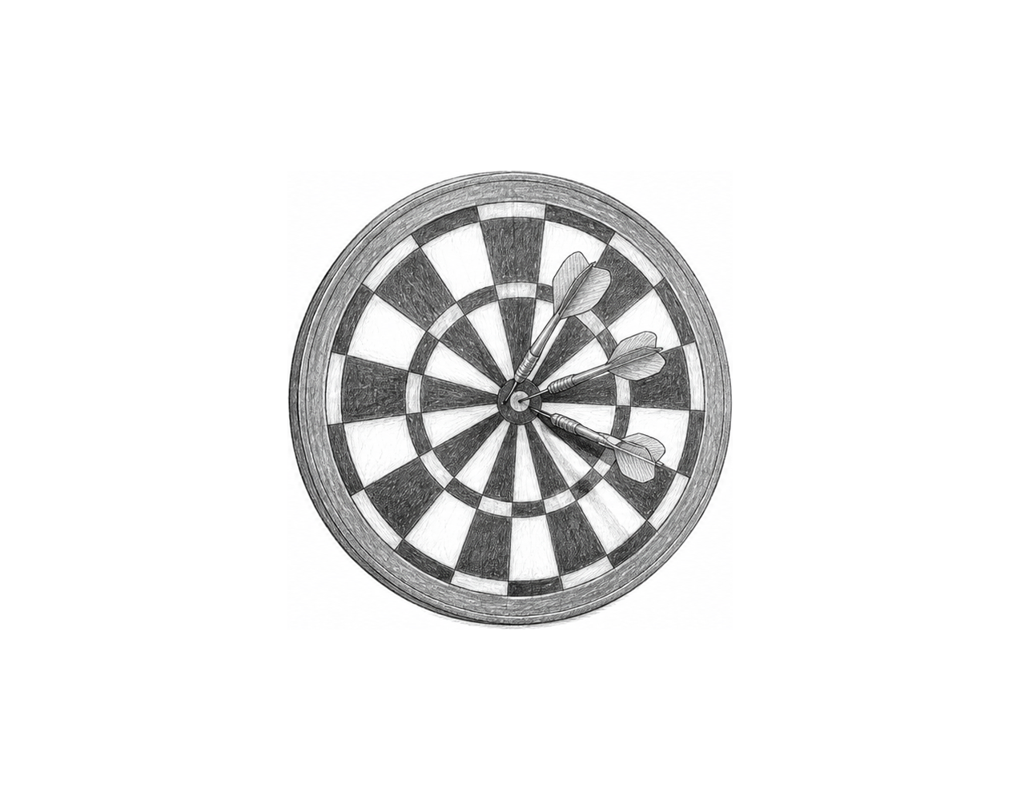

Challenge 2
Change the example so it rolls two dice. Use random.randint() twice and store the rolls in roll_one and roll_two , display both after "Rolls:", then display their sum after "Total:". Run it several times and check each total.

Challenge 3
Create a guessing program. Ask for a minimum and a maximum whole number, then use random.randint() to choose a target between them, including both. Ask the user to guess it. Display "Correct" or "The target was" followed by target . Test 4 and 4 with a guess of 4.

Random Whole Numbers

Fix the code!

This code has errors! Look closely at the code to find the problems:

import random
random.seed(7)
roll = random.randit(1 6)
print("Dice roll:", role)

Rewrite the whole program in the box below with fixes to the errors.
Click or tap here to enter text.

After you are confident that you fixed all the errors, copy the code from the box and run it.

Did it work correctly on your first try? Did you find all the errors?
Click or tap here to enter text.

